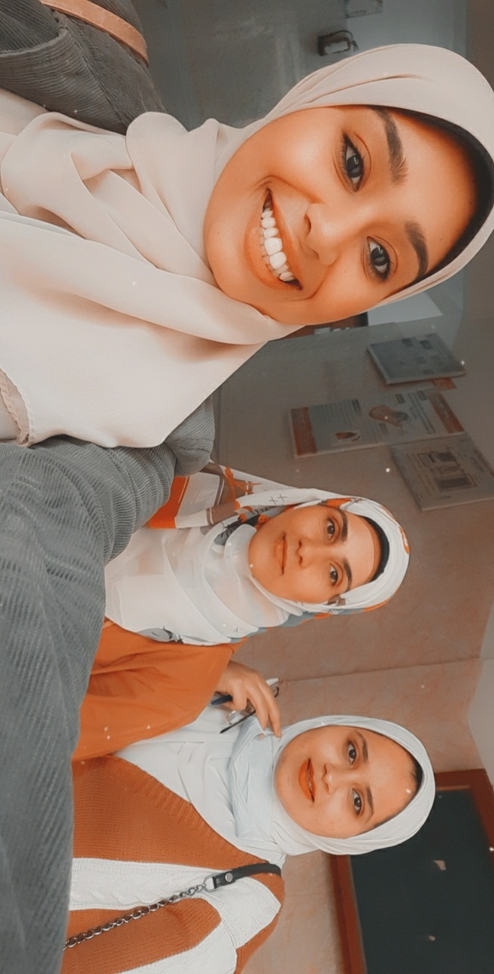CURRICULUM VITAE

Nadia Helal Abd El Hamied Ramadan

Date of birth: 20/9/1992

Gender: Female.

Marital Status: Married.

Nationality: Egyptian

E-mail: nadiahelal@aun.edu.eg

Website: http://www.aun.edu.eg/arabic/membercv.php?M_ID=6082.

Phone: +02 – 012 217 600 81

Address 1: Alqosia- Assiut-Egypt

Address 2: Assiut University-Faculty of Agriculture-Food Science and Technology department- Egypt.

**Education:**

**B.Sc.** from September 2009 to June, 2014 from Assiut university- Faculty of Agriculture. June 2014 B.Sc. Food and Technology, Assiut University, Egypt (Very good with Honor's grade).

**M.Sc.** from September 2015 to May 2020 from Assiut university- Faculty of Agriculture. May 2020 M.Sc. In Food Science and Technology, Faculty of Agriculture, Assiut University, Egypt.

**Thesis Title:**

Chemical and Nutritional Evaluation of Grapefruit (Citrus paradise L.) juice.

**Work experience:**

Demonstrator: from 16 joinery , 2015 to 17 June, 2020.

Assistant lecturer: from 17 June, 2020 to now.

**Teaching activity:**

Teaching undergraduate courses in principle of Food Technology, Food Analysis, Biochemistry, Industrial of sugar, Food Microbiology, Industrial Fermentation, Meat, Poultry and Fish Technology.

**Qualifications:**

* Computer Skills: ICDL (IT,Windows, word .Excel, Access , Powerpoint and Intern& E-Mail ).
* Arabic: Native language, English: foreign language
* Conference: the 7thscientific conference for agricultural sciences Hold on 30-31 October, 2016 Assiut university Egypt. The 8th scientific conference for agricultural sciences. 25-26 march 2019, Assiut University Egypt.
* Preparing the university teacher (29/7-3/8 2017 Faculty of Education Assiut university).
* Conference Organization (19-20 September 2017.FLDC Assiut university).
* Quality Standards in teaching (26-27September 2017.FLDC Assiut university).
* Statistical Analysis in Science Research (28-29 November 2017.FLDC Assiut university).
* Strategic planning (12-13 December 2017.FLDC Assiut university).
* How to Design the E-Course (29-30 September 2019 .FLDC Assiut university).
* Communication Skills (20-21October 2019 .FLDC Assiut university).

**Interests:**

1. **Sugar processing**
2. **Reffinig sugar**
3. **By products of sugar (molasses)**

**Published research:**

Nadia H. A.; M. A. Seleim; Manal A.M. Hassan; A. S.M. Saleh;: (2019):

|  |
| --- |
| **Physico-chemical Evaluation of White and Pink Grapefruit (Citrus paradisi) Juice.** |
|  |

Assuit . J. agr. Sci. Vol. 50, No. 3, pp. 112-122.

Web site: https://ajas.journals.ekb.eg/?_action=press&issue=-1&_is=Articles%20in%20Press.

**References:**

**1- Prof. Samy Ibrahiem El-syiad**

Professor, Department of Food Science and Technology, Faculty of Agriculture, Assiut University

E-mail : [elsyiad@aun.edu.eg](mailto:elsyiad@aun.edu.eg)

**2- Prof. Soumia Mohamed Ibrahim Darwish**

Professor and Head of Department of Food Science and Technology, Faculty of Agriculture, Assiut University

Website: <http://www.aun.edu.eg/membercv.php?M_ID=1261>

E-mail: [soumia.darwish@aun.edu.eg](mailto:soumia.darwish@aun.edu.eg)

**3- Dr. Ahmed Salah Moussa Saleh**

Lecturer, Department of Food Science and Technology, Faculty of Agriculture, Assiut University. Website: <http://www.aun.edu.eg/membercv.php?M_ID=1331>

E-Mail: ahmed.saleh@aun.edu.eg